**Superior University Reiwend Road**

.

Name: Haseeb Arshad

Roll no: SU92–BSSEM-F22-177

Section:5D

Subject: CN Lab  
Task 8

Submitted to: Sir Rasikh Ali

**Task 1:**

**Design network of "Lab-7" and “Lab-8” (2-3 rows of computers) Use: • Switch (2) • Router (1) • End-Devices like Laptop/PC Given IP Address (167.158.15.0), Create 4 Subnets from this given IP Address and use the “2” Subnets in the 2 networks connected to Router, using Command for Router. And Dynamically (DHCP-Router) for End-Devices**

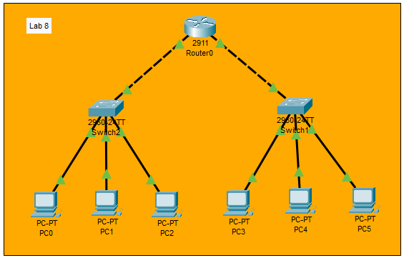

**Router Configuration:**

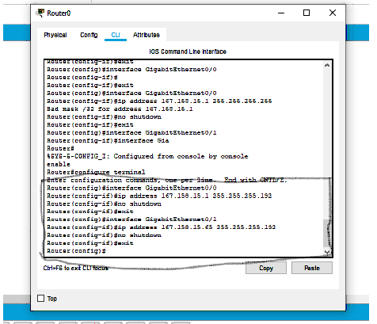

**Configure DHCP on both Networks:**

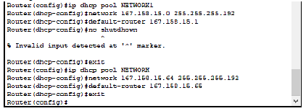

**Configure end devices:**

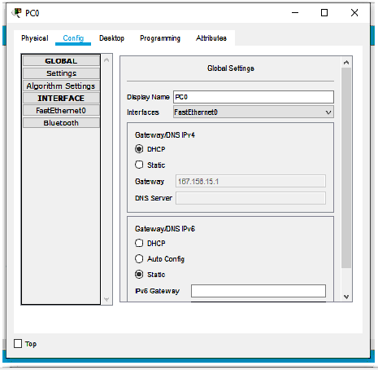

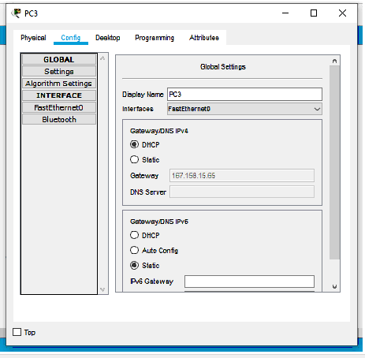

**Testing:**

